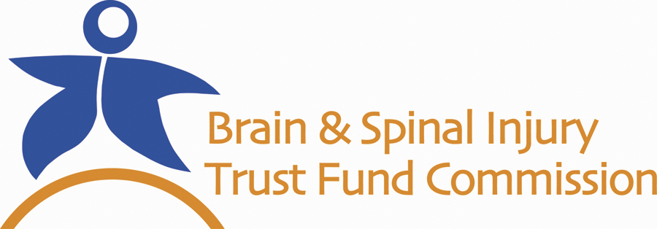

PREVIOUS AWARDS
TO PERSONS WITH A TRAUMATIC BRAIN INJURY

The Brain and Spinal Injury Trust Fund Commission was created to help Georgians with a traumatic brain or spinal cord injury with injury-related expenses. State residents with an eligible injury may apply for goods or services related to their injury; this request is not automatically approved.

Below are goods and services previously awarded to persons with a traumatic brain injury; they are grouped by need.

Since my brain injury I have a hard time with my balance or with walking.
- Walker
- Adaptive Aquatic (swimming) therapy
- Physical Therapy
- Neuromuscular Therapy
- Grab bars in the bathroom/shower
- Corrective shoes

My brain injury makes it difficult for me to read and learn.
- Academic tutoring
- Adaptive computer
- Cognitive rehab
- Computer
- Eye Q reading program
- Math tutor
- Reading and Comprehension program

I have vision problems now because of my brain injury.
- Visual Aids
- Training for vision devices
- Voice recognition software
- Zoom text software

I have a hard time being around other people since my brain injury.
- Behavioral Therapy
- Community re-entry program
- Family Therapy
- Life skills therapy
- Psychosocial therapy
- Social skills therapy

I have a hard time taking care of my personal hygienic needs since my brain injury.
- Adult care services
- Attendant care
- Bathroom modifications
- Diapers

I have a hard time remembering personal activities, appointments, things to do, etc.
- Palm pilot
- Electronic organizer
- PDA (personal data assistant)

I have a hard time accessing my vehicle.
- Vehicle modifications
- Wheelchair lift for van
- Hand control system
- Portable ramp

I need help getting to and from doctors appointments, school, work, etc.
- Attendant care
- GPS car navigational unit
- Modified van
- Vehicle

